APR Mid-Cycle Coversheet

In compliance with ABOR policy and in support of continuous program improvement, the APR Mid-Cycle Report will take place 3 ½ years after each 7-year comprehensive review. The report will track progress on APR recommendations and assessment of student learning outcomes. It will also enable Heads and Deans to address any challenges or opportunities that have arisen since the last program evaluation.

Process and Timeframe
Each March, the Office of the Provost will host an orientation for all programs scheduled to submit a Mid-Cycle Report.

Using the document created by the APR review committee, Heads and a broadly representative group of their unit will briefly report on actions taken—or reasons for deferred action—in response to each of the committee recommendations. The report will include a brief timeframe for remaining or on-going actions before the next APR. It will also account for progress on assessment of student learning outcomes and address any new program challenges or opportunities that have arisen since the last APR.

The Mid-Cycle Report will be due to the Office of the Provost and to the unit’s Dean by May 15. It should be collaborative and broadly representative of program stakeholders. If either the Head, Dean, or Associate Vice Provost for Academic Affairs requests a meeting in response to the report, it will be scheduled before the end of June.

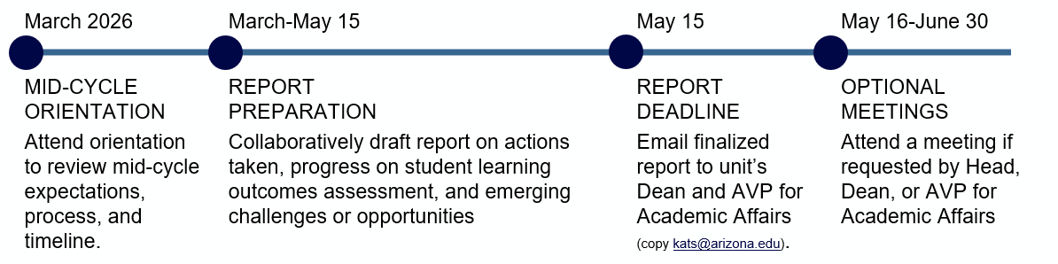

Resources and Support
The Associate Vice Provost for Academic Affairs, Meg Lota Brown, will oversee the mid-cycle process and represent the Provost in all aspects of the review. For questions about the report, contact Kat Francisco (kats@arizona.edu) in Academic Affairs.

For APR dashboard support with tracking changes to the unit’s data since the last APR, please contact the UAIR team: Jessica Calderwood (jcalderwood@arizona.edu) or Ashley Hurand (mclaren@arizona.edu).

For support with student learning outcomes assessment, please contact the UCATT team: Elaine Marchello (evm@arizona.edu) or Laurie Sheldon (lsheldon@arizona.edu).

Unit/Program Name:

Academic Program Review Mid-Cycle Report

- Program improvement and strategic planning
Please append the APR committee’s report and respond in italics to each recommendation, briefly describing the actions taken—or reasons for deferral of action. The response to each recommendation should include a brief timeframe for remaining or on-going actions before the next APR takes place. Please use the textbox below to explain briefly how the input of unit stakeholders was incorporated into your report.

- Progress on assessment of student learning outcomes
UCATT provides annual evaluations of each program’s work on student learning outcomes assessment. Please append a copy of your most recent evaluation. If the section entitled “Closing the Loop on Feedback” specifies either “partly” or “no,” use the text box below to describe your ongoing work in response to UCATT recommendations.

- Recent developments
If any new challenges or opportunities have arisen since the APR, please use the text box below to list each challenge or opportunity and outline briefly what steps have been taken to address them.

Optional Meeting (Check one):

☐ | Yes, I would like to request an optional meeting with the Dean and Associate Vice Provost.
☐ | No, I do not wish to request an optional meeting at this time, but I understand that the Dean and/or Associate Vice Provost may still initiate a meeting.

Signature |  | Date
Name, Title

